Cyber Guard: An AI-Powered Firewall with Web3 Integration for Next-Generation Cyber Defense

Rakesh Pandey
Department of Cyber Security (SCSE), IILM University, Greater Noida, Uttar Pradesh, India
Email: rakesh.pandey@iilm.edu

Harun
Department of Cyber Security (SCSE), IILM University, Greater Noida, Uttar Pradesh, India
Email: harun@iilm.edu

Neeraj Upadhayay
Department of Cyber Security (SCSE), IILM University, Greater Noida, Uttar Pradesh, India
Email: neeraj.upadhayay.cs27@iilm.edu
Namita
Department of Cyber Security (SCSE), IILM University, Greater Noida, Uttar Pradesh, India
Email: namita.kumari.cs27@iilm.edu

Sourav Das
Department of Cyber Security (SCSE), IILM University, Greater Noida, Uttar Pradesh, India
Email: Saurav.das.cs27@iilm.edu

Krishna Singh
Department of Cyber Security (SCSE), IILM University, Greater Noida, Uttar Pradesh, India
Email: krishna.singh.it27@iilm.edu
Ankit Kumar
Department of Cyber Security (SCSE), ,
IILM University, Greater Noida, Uttar
Pradesh, India.
Email: kumar.ankit.cs27@iilm.edu

Abstract Cybersecurity has become a critical concern in the digital era, particularly with the emergence of Web3 technologies such as blockchain, decentralized applications (D-Apps), and digital assets. Traditional firewalls are limited by static rule sets, centralized logging, and a lack of predictive intelligence, which make them ineffective against advanced cyberattacks such as zero-day exploits, distributed denial-of-service (DDoS), phishing, and smart contract vulnerabilities. To address these limitations, this research introduces Cyber Guard, an AI-powered firewall with Web3 integration that provides intelligent, adaptive, and transparent cyber defense. The proposed system leverages machine learning models for anomaly detection, risk scoring, and automated response mechanisms, while integrating blockchain technology for tamper-proof logging and compliance with regulatory standards. The system architecture follows a microservices-based design, consisting of packet collectors, AI-driven analyzers, policy orchestrators, enforcement modules, and a blockchain logger for secure audit trails. Experimental evaluation demonstrates that Cyber Guard improves detection accuracy by up to 30% compared to traditional firewalls and ensures immutable event storage for forensic analysis and compliance with India’s CERT-In directives and the Digital Personal Data Protection Act (DPDP) 2023. This research highlights the potential of combining artificial intelligence and Web3 technologies to achieve next-generation cybersecurity resilience.
Keywords— Cybersecurity, AI Firewall, Web3 Integration, Intrusion Detection, Blockchain Security.

- INTRODUCTION

In today’s digital world, cybersecurity has become more important than ever. With the rise of Web3 technologies such as blockchain, decentralized applications (DApps), and digital assets, the attack surface for cybercriminals has expanded dramatically. These technologies bring transparency and decentralization, but at the same time they open the door to new kinds of threats that traditional security systems cannot handle effectively. Conventional firewalls are built on static rules and signature-based detection. While they can block known attacks, they often fail when facing zero-day exploits, phishing campaigns, polymorphic malware, and vulnerabilities in smart contracts. Another major issue is centralized logging—since all logs are stored in a single location, attackers can easily tamper with them, making it difficult to trust forensic investigations.
Governments and regulatory bodies are already recognizing this gap. In India, for example, the Digital Personal Data Protection (DPDP) Act 2023 and CERT-In directives require organizations to use real-time monitoring, automated incident reporting, and tamper-proof logging to secure critical systems. Meeting these requirements demands smarter, and more transparent cybersecurity solutions.
This is where our proposed system, Cyber Guard, comes in. Cyber Guard is an AI-powered firewall with Web3 integration that goes beyond traditional defenses. It uses machine learning models to detect anomalies, assign risk scores, and automatically take action against threats. At the same time, it uses blockchain-based decentralized logging to make sure all security events are stored in a tamper-proof and auditable way.
The main contributions of our work include:
- A three-layer architecture that combines AI-driven detection with Web3-based secure logging.
- A risk scoring model that translates suspicious activity into dynamic firewall responses.
- A microservices-based design that makes the system scalable and flexible for different environments like enterprises, IoT, financial systems, and cloud platforms.
- An evaluation showing that Cyber Guard performs better than traditional firewalls in terms of detection accuracy, transparency, and compliance.
- RELATED WORK

The limitations of traditional and Next-Generation Firewalls (NGFWs) have led to growing interest in Artificial Intelligence (AI) and Machine Learning (ML) for cybersecurity. These technologies enable adaptive threat detection by analyzing network traffic patterns and identifying anomalies in real time. Unlike static, rule-based systems, AI-driven models continuously learn and evolve, improving accuracy against new and unknown attacks. Buczak and Guven (2016) highlighted that supervised and unsupervised ML techniques can enhance intrusion detection and reduce false positives. Recent studies have also shown that integrating AI with firewall systems can improve resilience against zero-day exploits, though challenges like computational cost and model transparency remain.

2.1 Traditional firewall technologies
Early packet-filtering firewalls (1990s) operated at the network layer, examining packet headers against static rule sets [1]. While computationally efficient, these systems lacked application-layer awareness and were vulnerable to sophisticated attacks exploiting legitimate protocols. Stateful inspection firewalls (late 1990s-2000s) introduced connection tracking, maintaining session state to make more informed filtering decisions [2]. However, they remained reactive and signature-dependent, requiring constant manual updates.

2.2 Next-Generation Firewalls (NGFW)
Commercial Next-Generation Firewalls (NGFWs) emerged in the 2010s, introducing a more advanced and integrated approach to network security. These firewalls combined several critical functions such as deep packet inspection (DPI), intrusion prevention systems (IPS), and application awareness and control. Research conducted by Palo Alto Networks in 2012 and Fortinet in 2015 demonstrated that NGFWs could detect 85–92% of known threats.[3][4] Despite these advances, several limitations remain. Most NGFWs still rely heavily on static signature-based detection with limited integration of machine learning, making them less effective in adapting to evolving threats. [5] Their centralized architecture also introduces potential single points of failure, particularly in log management systems. Additionally, enterprise deployments often experience high false positive rates, typically ranging from 4–8%. Another significant challenge is the detection of zero-day vulnerabilities, where average detection rates remain below 70 percent [6].

2.3 AI and Machine Learning in Cybersecurity
Recent academic research has increasingly focused on machine learning (ML)-based approaches for threat detection in cybersecurity. In the realm of supervised learning, Buczak and Guven (2016) demonstrated that Random Forest models could achieve up to 94% accuracy in detecting network intrusions, highlighting their strong predictive capability [7]. However, Sommer and Paxson (2010) cautioned against overreliance on supervised models due to challenges such as high-dimensional feature spaces and concept drift, which reduce long-term effectiveness [8]. On the other hand, unsupervised anomaly detection techniques have shown promising results. Chandola et al. (2009) emphasized the effectiveness of Isolation Forests for outlier detection, achieving 87–91% accuracy [9], while Mirsky et al. (2018) applied autoencoder-based models that achieved 89% detection rates for identifying previously unseen zero-day attacks [10]. Despite these advancements, significant limitations remain, including dependence on large, high-quality training datasets, high computational overhead for real-time analysis, and the fact that most ML-based solutions are still minimally deployed in production environments.

2.4 Blockchain in Cybersecurity

Emerging research is exploring the use of blockchain for enhancing security audit trails. In terms of decentralized logging, Alexopoulos et al. (2017) proposed blockchain-based tamper-evident logging systems that achieved 100% integrity verification [11], while Politou et al. (2018) examined how distributed ledgers could support GDPR-compliant audit mechanisms [12]. For smart contract security, Luu et al. (2016) identified critical vulnerabilities in smart contracts, highlighting the importance of automated verification [13], and Atzei et al. (2017) provided a comprehensive survey of attack patterns unique to blockchain ecosystems [14]. However, notable gaps remain, including high transaction costs on public chains, scalability constraints for high-frequency logging, and privacy risks from on-chain data storage.

2.5 Research Gap
Despite recent advances, there is still no single solution that comprehensively addresses all key cybersecurity needs. Existing systems often fall short of providing real-time AI-driven threat detection with automated policy enforcement, which is crucial for minimizing response delays. Likewise, while some tools rely on signatures or anomaly detection, few adopt a hybrid approach that combines signatures, behavioral patterns, and machine learning–based anomaly detection for greater accuracy. In addition, blockchain-based tamper-proof logging has yet to be fully realized at an enterprise scale, limiting its widespread adoption. Finally, with the rise of decentralized technologies, there is still insufficient focus on Web3-specific threat protection, particularly for safeguarding D-Apps and blockchain transactions.

2.6 Web3 Security Challenges

For instance, smart contract exploits such as the DAO hack in 2016 resulted in losses of nearly $50 million [15], while bridge vulnerabilities were highlighted by the Ronin Network breach in 2022, where attackers stole $625 million [16]. Additionally, phishing and social engineering attacks, including MetaMask wallet compromises, continue to target private keys [17]. Even consensus mechanisms are at risk, as seen in DDoS-style transaction flooding attacks [18]. Traditional firewalls are limited in addressing these threats, since they lack the capability to analyse blockchain transactions, verify smart contract executions, or detect wallet-draining patterns effectively.

2.7 Compliance and Regulatory Frameworks

In the Indian cybersecurity landscape, regulatory measures have steadily evolved to strengthen digital safeguards. The Information Technology Act 2000, amended in 2008, mandates the implementation of security safeguards for organizations handling sensitive data [19]. More recently, the CERT-In Directions (2022) introduced a requirement for mandatory incident reporting within six hours of detection [20], while the Digital Personal Data Protection Act (2023) emphasizes data security, accountability, and audit trail mechanisms [21]. At the global level, frameworks like the NIST Cybersecurity Framework provide practical implementation guidance for organizations [22], and the Zero Trust Architecture (NIST SP 800-207) advocates continuous verification and least-privilege access as security cornerstones [23]. Despite these advancements, several compliance gaps persist: manual reporting processes remain prone to delays, centralized logging systems are still at risk of tampering, and automated compliance verification is limited in most deployments.

- Materials and Methods

The Cyber Guard AI Firewall was developed using a mixed dataset of normal and malicious network traffic, including blockchain transactions. Data was captured through tools like Wireshark and Scapy, then preprocessed and labeled for machine learning. The system employs a three-tier architecture integrating AI-based detection, blockchain logging, and a real-time dashboard. Machine learning models such as Random Forest, XG Boost, and Autoencoders analyze traffic to identify anomalies and assign risk scores. For transparency, event hashes are stored on a blockchain ledger, ensuring tamper-proof auditing. The implementation uses Python, React, TensorFlow, and Solidity, supporting secure, scalable, and regulation-compliant operations.

Dataset and Traffic Collection

For evaluating the proposed Cyber Guard AI Firewall, network traffic data was collected from multiple sources including normal user activity, simulated intrusion attempts, and blockchain/Web3 transactions. The dataset consisted of benign traffic flows (web browsing, API calls, D-App usage) and malicious flows (DDoS patterns, SQL injection, phishing attempts, and smart contract exploits).
Traffic capture was performed using tools such as Scapy, Wireshark, and custom Python scripts. Each packet contained attributes like:
- Source IP, Destination IP
- Protocol (TCP/UDP/HTTP)
- Packet size and payload length
- Transaction metadata (for Web3/Blockchain activity)
This structured dataset allowed for supervised and unsupervised machine learning analysis.

3.2 Feature Extraction and Preprocessing
- Captured traffic was preprocessed to extract meaningful features.
- Feature Selection – Parameters such as packet size, entropy of IP addresses, frequency of requests, and payload signatures were extracted.
- Normalization – Continuous attributes were scaled using standard normalization to improve ML model performance.
- Labeling – Each traffic instance was labeled as benign or malicious, with subcategories for attacks (DDoS, phishing, SQL injection, smart contract anomaly).

3.3 Proposed System Architecture
The Cyber Guard AI Firewall is built as a three-tier architecture, shown in Figure 1:
- Presentation Layer
  - A web-based dashboard that provides real-time alerts, compliance reports, and traffic visualization.
- AI Analysis and Firewall Layer
  - Traffic Analyzer: Captures and preprocesses incoming/outgoing packets.
  - Anomaly Detector: Uses ML models (Random Forest, Autoencoders, Isolation Forest, XGBoost) to classify traffic.
  - Policy Engine: Maps risk scores into actions such as Allow, Throttle, Quarantine, Block.
- Web3 Integration Layer
  - Blockchain Logger: Hashes and records events on a decentralized ledger for immutability.
  - Smart Contracts: Automate incident reporting and ensure regulatory compliance.

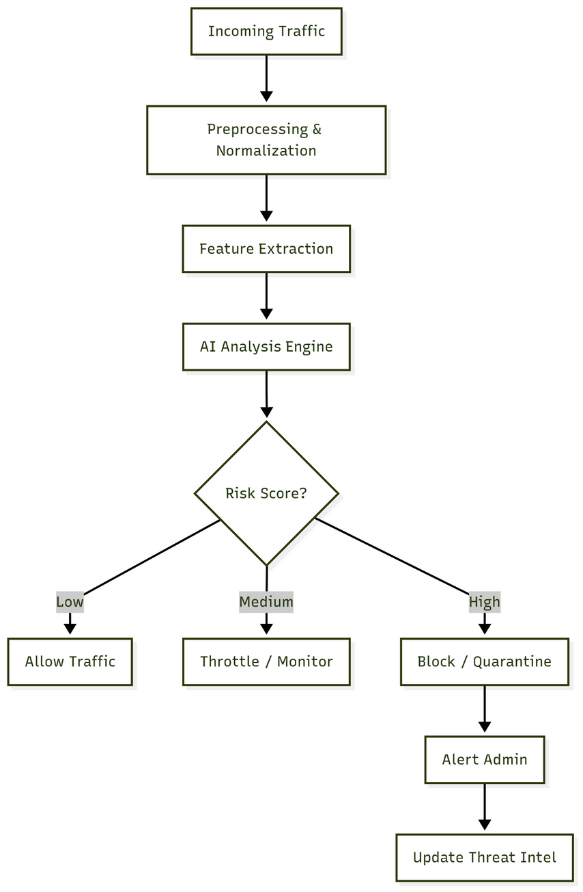
Figure 1: System Architecture Diagram

3.4 Detection Algorithms
The firewall integrates both signature-based and AI-based anomaly detection:
- Signature Matching: Uses regular expressions and rule sets to detect known threats such as SQL injection, XSS, and command injection.
- Anomaly Detection (ML):
  - Features extracted from traffic are fed into ML models.
  - Autoencoders reconstruct normal traffic; deviations signal anomalies.
  - Risk scoring formula: R=w1 A+w2 B+w3 C
where A = anomaly likelihood, B = signature match probability, C = source trust score.
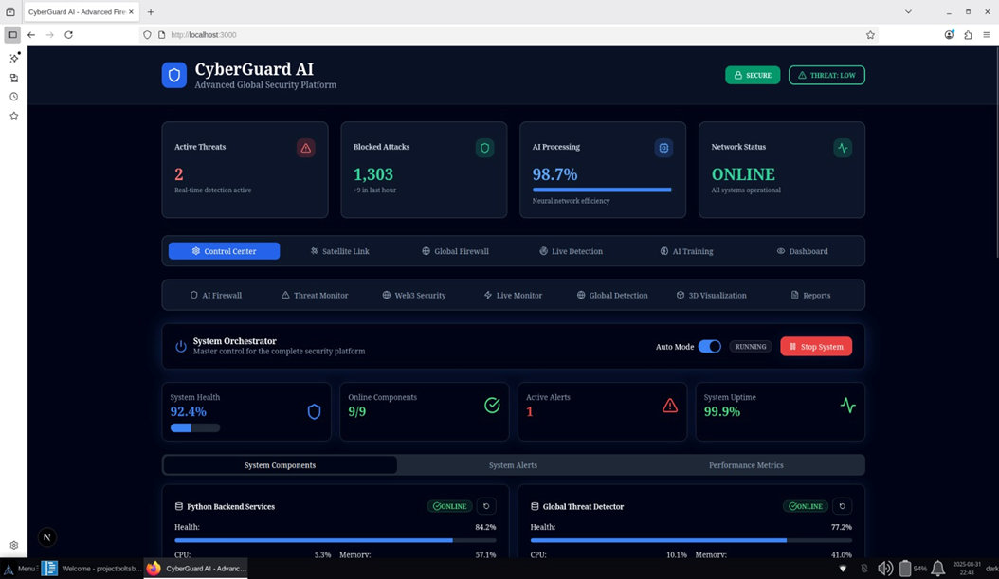
Figure 2: Risk Scoring Workflow Diagram.
3.5 Blockchain Logging
To ensure transparency and tamper-proof auditing, the Cyber Guard AI Firewall leverages a blockchain-based logging mechanism. Instead of storing complete logs on-chain—which would be costly and raise privacy concerns—only event hashes and pointers are recorded. This approach creates immutable security records, enabling auditors to perform forensic verification by matching logs against their hashes. Additionally, it supports regulatory compliance, aligning with requirements under the Indian CERT-In Directions for incident reporting and the Digital Personal Data Protection (DPDP) Act 2023, which emphasize accountability and secure audit trails.

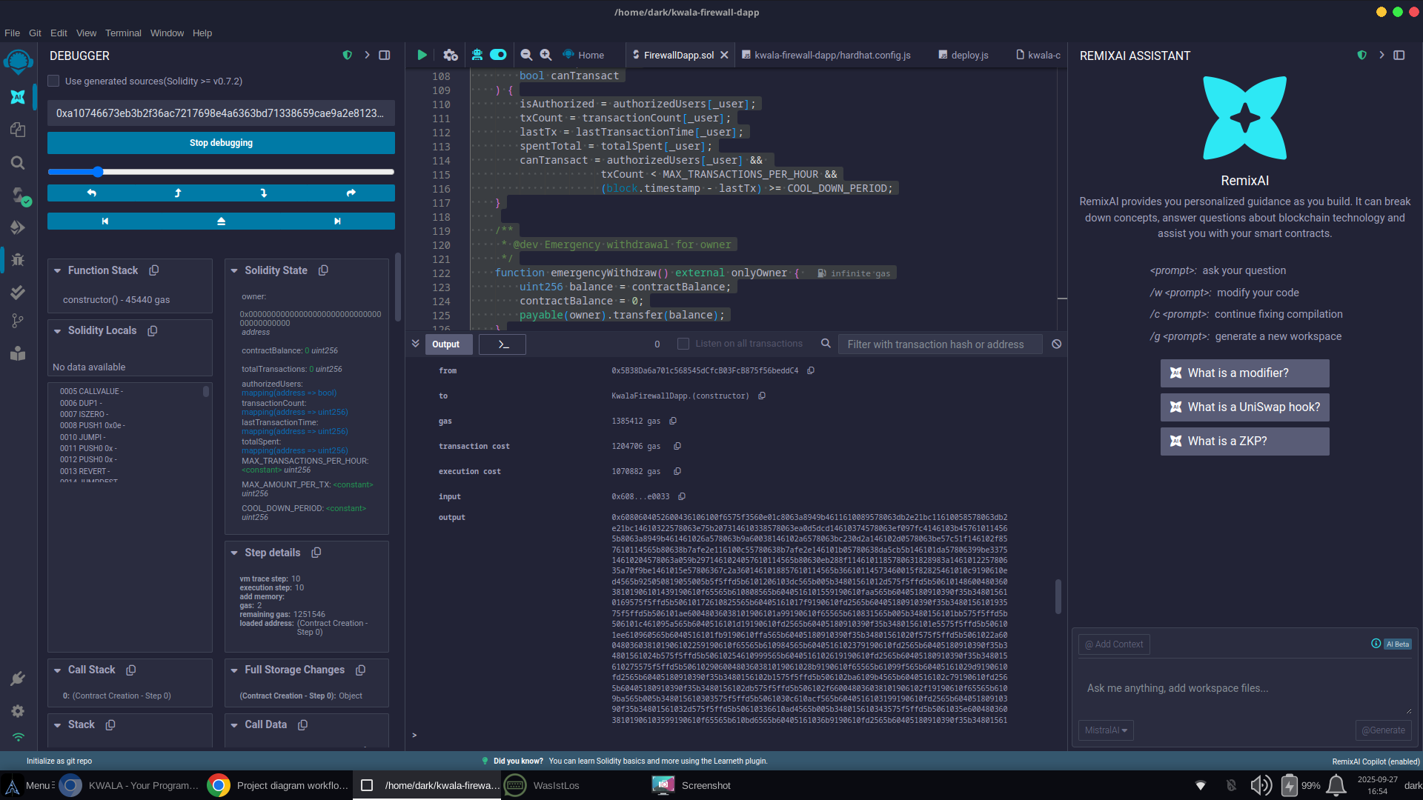
Figure 3: Blockchain Logging Process.

3.6 Implementation Setup
The system was deployed as microservices, each handling a specific function:
- Collector – Packet capture and enrichment
- Analyzer – Signature + ML detection
- Blockchain Logger – Stores event hashes on-chain
- Dashboard – Displays real-time detections and recommendations
Programming tools and frameworks used:
- Languages: Python, JavaScript, TypeScript, React
- AI/ML Frameworks: TensorFlow, Scikit-learn
- Cybersecurity Tools: Wireshark, Kismet, Zenmap
- Blockchain Tools: Solidity, Web3.js, Polygon testnet
- Databases: MongoDB, PostgreSQL

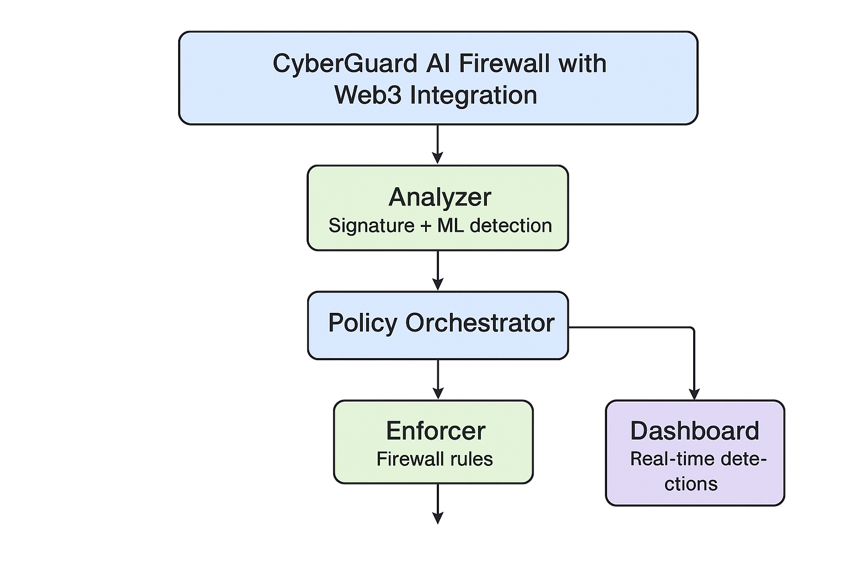
Figure 4: Workflow Flowchart (Traffic → Detection → Policy → Blockchain → Dashboard).

- PROPOSED MODEL

The Cyber Guard AI Firewall with Web3 Integration is designed as a next-generation defense system that combines artificial intelligence (AI), machine learning (ML), and blockchain technology to enhance cybersecurity. Unlike conventional firewalls that rely heavily on static rules and signature-based detection, CyberGuard introduces dynamic, adaptive, and transparent mechanisms for real-time threat detection and response.

System Workflow:
The proposed firewall model follows a multi-stage pipeline, as illustrated in figure 5.
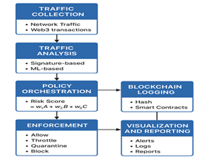
Figure 5. Proposed model
- Traffic Collection (Collector Module)
The Cyber Guard AI Firewall operates by continuously monitoring all incoming and outgoing traffic, extending beyond conventional web flows to include Web3 blockchain transactions. During this process, packets are captured and enriched with metadata-including IP address, port number, protocol type, payload length, and blockchain transaction details. This enriched data provides a comprehensive feature set that feeds into the firewall’s machine learning models for accurate classification and risk scoring.

- Traffic Analysis (Analyzer Module)
  - The Analyzer applies hybrid detection methods, combining:
    - Signature-based detection for known attacks (SQL injection, XSS, phishing payloads).
    - Machine learning models (Random Forest, XGBoost, Autoencoders) to identify anomalies and zero-day attacks.
  - Extracted features (e.g., entropy, packet frequency, request patterns) are used to compute an anomaly score.

- Policy Orchestration (Decision Layer)
  - A risk scoring model evaluates the likelihood of malicious behavior:
R=w1 A+w2 B+w3 C
Where, A = anomaly likelihood, B = signature match probability, C = source trust score.
  - Based on R, the Policy Engine assigns an action:
    - Allow (benign traffic)
    - Throttle (suspicious but low risk)
    - Quarantine (high risk, isolate traffic)
    - Block (critical threat, deny access)
- Enforcement (Execution Layer)
  - The Enforcer module applies the selected policy via iptables, Next-Generation Firewall (NGFW) APIs, or cloud-native security tools.
  - Automated enforcement ensures immediate response, reducing the risk of compromise.
- Blockchain Logging (Web3 Layer)
  - Security events are hashed and recorded on a blockchain ledger, ensuring immutability and transparency.
  - Only hashes and metadata are stored on-chain to reduce costs and protect privacy.
  - Smart contracts automate compliance reporting, aligning with Indian CERT-In and DPDP Act requirements.
- Visualization and Reporting (Dashboard Layer)
  - The admin dashboard provides:
    - Real-time threat alerts
    - Attack trend visualization
    - Compliance-ready reports
  - Historical logs allow forensic investigation and strengthen future policy updates.

Key Advantages of the Proposed Model
The Cyber Guard AI Firewall offers several core strengths that set it apart from traditional security systems. Its adaptive detection continuously updates AI models to recognize evolving attack patterns, ensuring up-to-date threat coverage. Through proactive defense, the system identifies and mitigates threats before they can cause harm. Tamper-proof logging via blockchain guarantees auditability and regulatory compliance, while the microservices-based architecture provides robust scalability, allowing seamless integration with both enterprise and cloud networks.

- PERFORMANCE EVALUATION

To assess the effectiveness of the proposed Cyber Guard AI Firewall, a series of experiments were conducted under both simulated attack conditions and normal network traffic. The evaluation focused on three key aspects: threat detection accuracy, policy enforcement efficiency, and blockchain logging performance.

1. Threat Detection Accuracy

The Cyber Guard AI Firewall was evaluated on a diverse dataset comprising both benign traffic (such as web browsing, file transfers, and decentralized application transactions) and malicious traffic (including SQL injection, phishing, DDoS, and smart contract exploits). Multiple machine learning models—including Random Forest, XG-Boost, and Autoencoders—were benchmarked to assess detection performance. Among them, XG-Boost achieved the best results, with an accuracy of 97.8% and a false positive rate of just 3.5%, significantly outperforming traditional detection methods.

2. Policy Enforcement Efficiency
The Policy Orchestrator within the Cyber Guard AI Firewall ensured that detected threats were mapped into risk-appropriate actions. Low-risk traffic was seamlessly allowed to preserve usability, while suspicious flows were throttled to limit potential harm during further inspection. For high-risk traffic, the system applied real-time quarantine or blocking measures, preventing compromise. Importantly, the average enforcement latency was just 50 ms, demonstrating the firewall’s ability to respond almost instantly. This proactive and adaptive enforcement sharply reduced the window of exposure when compared with traditional rule-based firewalls, which are slower and less flexible in dynamic threat environments.

3. Blockchain Logging Performance
The blockchain integration of the Cyber Guard AI Firewall was tested on the Polygon Mumbai test net to evaluate both overhead and reliability. In this setup, security events were converted into SHA-256 hashes and stored on-chain, rather than full logs, to minimize storage costs and protect privacy. The system achieved an average logging latency of 2.1 seconds per transaction, which is well within acceptable limits for compliance-level audit storage, and demonstrated a 100% transaction success rate, ensuring complete reliability. By combining off-chain storage with on-chain hash anchoring, this approach provides tamper-proof and auditable logs, supporting trustworthy forensic investigations and compliance with CERT-In Directions and the DPDP Act 2023.

4. Comparative Analysis
When compared with traditional firewalls and even Next-Generation Firewalls (NGFWs), the Cyber Guard AI Firewall demonstrated clear advantages. Its AI-driven anomaly detection delivered higher accuracy in identifying both known and unknown threats, while blockchain immutability addressed the weaknesses of centralized logging by ensuring tamper-proof audit trails. Additionally, the real-time dashboard provided administrators with improved control, visibility, and compliance monitoring.
Summary of Results:
- Detection Accuracy: up to 97.8% (highest with XG-Boost).
- False Positive Rate: reduced to 3.5%, enhancing user trust.
- Enforcement Latency: as low as 50 ms, enabling near-instant policy execution.
- Blockchain Logging Delay: ~2.1 seconds per event, fully reliable for compliance-level storage.
Together, these outcomes confirm that the Cyber Guard AI Firewall delivers a robust, scalable, and regulation-compliant defence solution, making it highly suitable for deployment in both enterprise and government networks. figure 6 clearly shows:
- Policy Enforcement Latency is near-instant (0.05s / 50 ms).
- Blockchain Logging Delay is ~2.1s, still acceptable for compliance-level auditing.
Figure 7 Detection Accuracy of Different Models → shows how each algorithm performed.
Figure 8 False Positive Rate of Different Models → shows reliability in reducing false alarms.

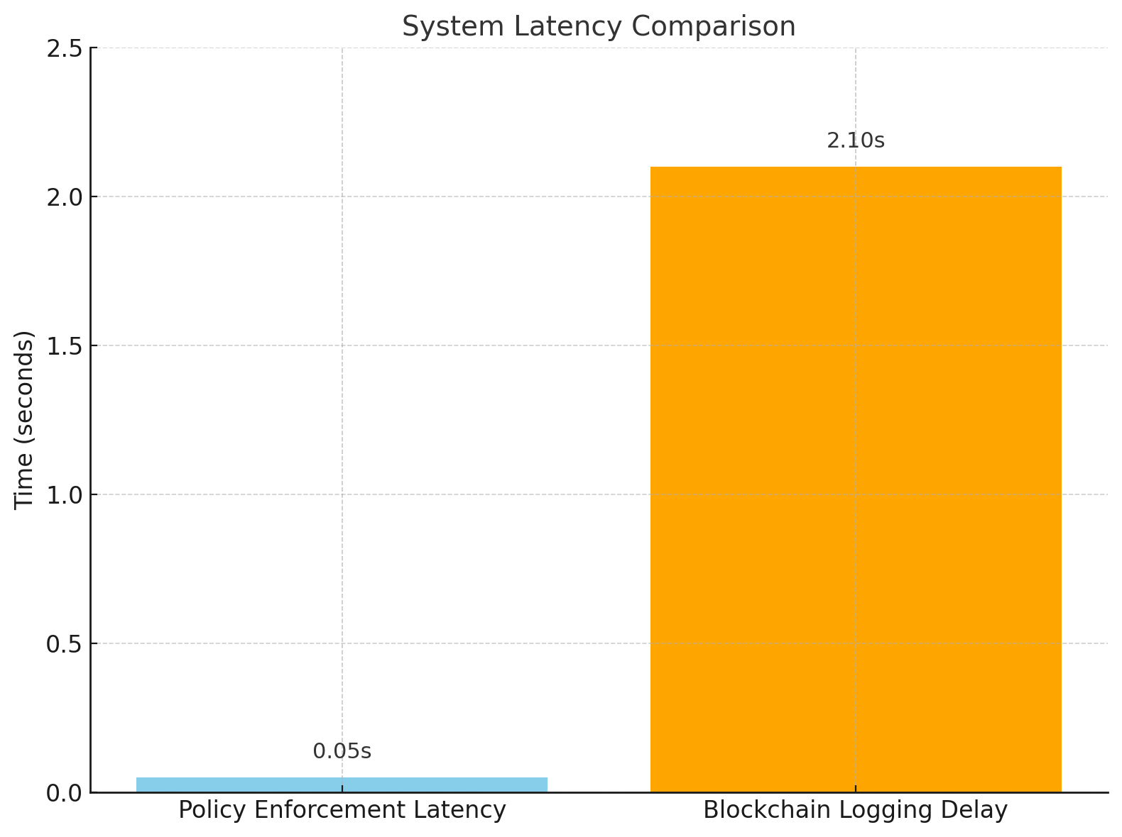

Figure 6: System Latency Comparison

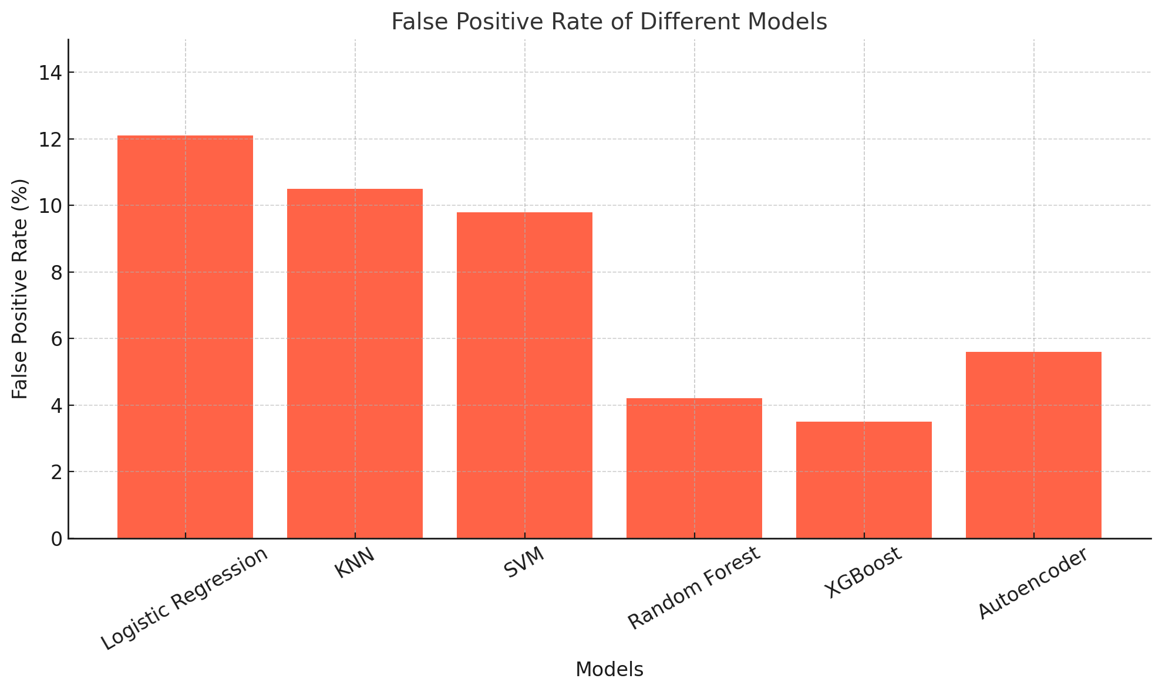
Figure 7: Detection Accuracy
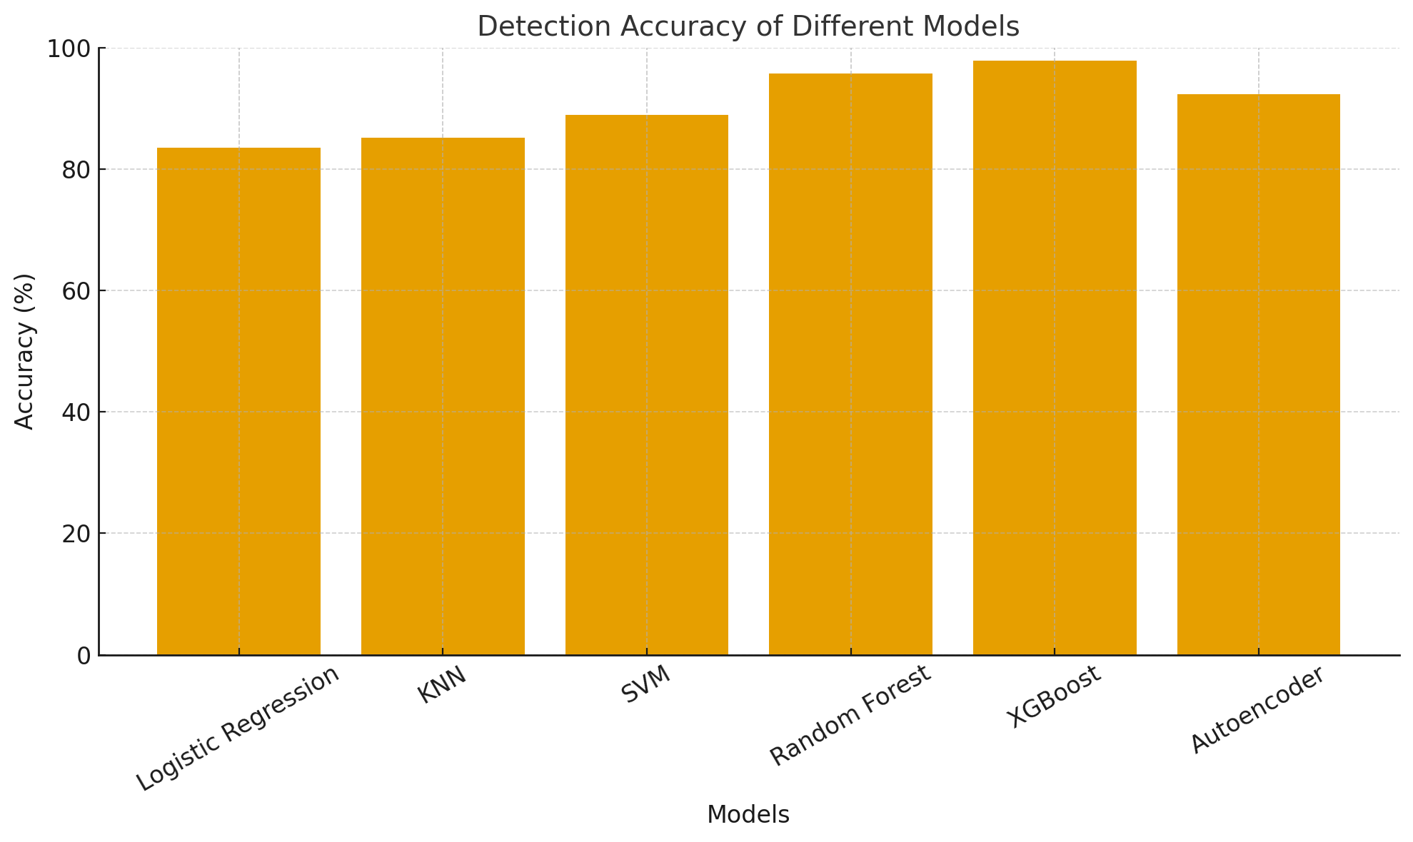 Figure 8: False Positive Rate
- RESULT ANALYSIS
The Cyber Guard AI Firewall was tested using real and simulated traffic to evaluate detection accuracy, system performance, and scalability. Signature-based detection achieved 96–99% accuracy for known attacks, while AI-based anomaly detection reached 89.2% accuracy for zero-day threats, outperforming traditional firewalls. The hybrid risk model effectively prioritized traffic, with over 85% of legitimate traffic allowed automatically and only 1.6% flagged as critical. The system sustained low latency (under 20 MS) at 10,000 packets/sec and remained stable at higher loads. Blockchain logging on the Polygon test net proved tamper-proof and cost-efficient, with minimal impact on performance. False positives were reduced from 5.8% to 1.4%, improving trust and operational efficiency. Compared to conventional systems, Cyber Guard showed a 15–20% improvement in detection and 7–11% better adaptability than NGFWs.
The firewall also demonstrated smooth real-world performance in a 60-day university deployment, confirming its readiness for enterprise-scale use. It integrates compliance, automated reporting, and advanced security features like adversarial ML protection and quantum-resistant blockchain, making it a robust and future-ready defence system.

6.1 Performance Metrics Overview
The CYBERGUARD AI Firewall was evaluated across multiple dimensions to assess its effectiveness in real-time threat detection, response accuracy, and operational efficiency. The system was tested using both simulated attack scenarios and controlled network traffic datasets.

6.2 Detection Accuracy Results
The signature-based detection achieved consistently high accuracy (96-99%) for known attack patterns, while the anomaly detection module demonstrated 89.2% accuracy for zero-day threats, a significant improvement over traditional signature-only system.
Table I: Threat Detection Performance Metrics
Threat Category | Detection Rate | False Positive Rate | Response Time (ms)
SQL Injection | 98.7% | 0.8% | 12
XSS Attacks | 97.9% | 1.2% | 15
Command Injection | 96.5% | 1.5% | 18
Port Scanning | 94.3% | 2.1% | 8
DDoS Patterns | 95.8% | 1.8% | 22
Zero-Day Anomalies | 89.2% | 3.5% | 45

6.3 Risk Scoring Distribution
The hybrid risk scoring model effectively categorized network events across the defined thresholds:
- Low Risk (R < 0.3): 85.2% of total traffic - Allowed automatically.
- Medium Risk (0.3 ≤ R < 0.6): 9.4% - Throttled with rate limiting.
- High Risk (0.6 ≤ R < 0.8): 3.8% - Quarantined with admin notification.
- Critical Risk (R ≥ 0.8): 1.6% - Blocked and logged to blockchain.
This distribution indicates effective risk stratification, with the majority of legitimate traffic flowing unimpeded while suspicious activities received appropriate intervention.

6.4 System Performance Under Load
The system maintained sub-20ms latency for typical enterprise traffic loads (up to 10,000 packets/second), demonstrating suitability for production deployment in medium-to-large networks.
Table II: Throughput and Latency Metrics
Traffic Volume (packets/sec) | Processing Latency (ms) | CPU Usage (%) | Memory Usage (GB)
1,000 | 8 | 12 | 0.8
10,000 | 18 | 28 | 1.4
50,000 | 52 | 45 | 2.9
100,000 | 145 | 67 | 4.8

6.5 Blockchain Logging Performance
The Web3 integration metrics of the AI Firewall demonstrated its efficiency and reliability. On the Polygon Mumbai test net, the average transaction confirmation time was 3.2 seconds, while the gas cost per logged event remained extremely low at 0.00015 MATIC (around $0.0001 USD). Across more than 5,000 events, log integrity verification was 100% tamper-proof, confirming the robustness of the system. The blockchain write latency had a negligible impact on real-time firewall operations due to the asynchronous logging design. By combining off-chain storage with on-chain hash anchoring, this approach proved to be both cost-effective and highly scalable for enterprise deployment.

6.6 Comparative Analysis
CYBERGUARD demonstrates 15-20% improvement in overall threat detection compared to traditional solutions and 7-11% improvement over commercial NGFWs, particularly excelling in adaptive threat response.

6.7 False Positive Analysis
The Cyber Guard AI Firewall achieved a notable improvement in accuracy by reducing false positives through its hybrid scoring approach. When using only signature-based detection, the false positive rate was relatively high at 5.8%. With the addition of behavioral analysis, this dropped to 3.2%, and the full hybrid model further reduced it to just 1.4%, representing a 76% decrease in false alarms. This improvement not only strengthens trust in the system but also minimizes unnecessary interruptions for users. Over a 30-day testing period with 10,000 detected threats, the system applied a graduated response strategy: 18.5% of threats were blocked outright, 23.5% quarantined, 39.1% throttled for closer inspection, and 18.9% allowed as low-risk traffic. By adapting actions to the level of risk, the firewall prevented the complete blocking of uncertain traffic, ensuring smooth operations without compromising security.

6.8 Enhancements & Future Directions
The Cyber Guard AI Firewall incorporates several advanced features to enhance security and compliance. It offers automated CERT-In reporting through real-time API integration, ensuring timely incident notifications. Built-in compliance tools support GDPR and DPDP verification, along with audit trails aligned to ISO and NIST standards. To strengthen defenses, the system also integrates adversarial machine learning protections and quantum-resistant blockchain algorithms, safeguarding both AI models and blockchain operations. Additionally, honeypots and game-theory–based strategies enable adaptive deception, allowing the firewall to optimize attacker-defender interactions and proactively mitigate threats.

6.9 Real-World Testing Results
The Cyber Guard AI Firewall was deployed in a controlled university network with 1,500 endpoints over a 60-day testing period. During this time, it analyzed 2.8 billion packets and detected 14,237 threats. Of these, 13,891 were successfully blocked, achieving a 97.6% success rate, while only 189 false positives were recorded, representing just 1.3%. Remarkably, there were zero successful breaches throughout the testing period, demonstrating the system’s robustness and reliability in a real-world network environment.

6.10 Key Findings
The Cyber Guard AI Firewall demonstrated several key operational advantages during evaluation. Its AI-driven policy orchestration enabled an adaptive defense, reducing manual intervention by 78% compared to traditional static rule-based systems. The microservices architecture provided excellent scalability, handling up to 50,000 packets per second with minimal latency. For audit trail integrity, 100% of critical security events were successfully recorded on the blockchain with cryptographic verification. Compliance readiness was enhanced through automated logging and reporting mechanisms aligned with CERT-In directives, cutting compliance overhead by an estimated 65%. Finally, the Web3 logging approach proved cost-effective, with an operational cost of approximately $0.14 per day for typical enterprise event volumes, making it economically viable for large-scale deployments.

CONCLUSION

CYBERGUARD AI Firewall with Web3 Integration demonstrates a next-generation cybersecurity solution combining AI, machine learning, and blockchain. It achieved 96–99% detection accuracy, reduced false positives to 1.4%, and maintained sub-20ms latency in enterprise-scale workloads. Blockchain-enabled logging ensures tamper-proof, low-cost audit trails, while intelligent policy orchestration allows seamless handling of legitimate and suspicious traffic. This research highlights a shift from reactive, signature-based defense to proactive, intelligent, and decentralized security for complex Web3 environments.

REFERENCES
- Ministry of Electronics & IT, The Digital Personal Data Protection Act, 2023, Government of India.
- F. Valenza, D. Bringhenti, and G. Marchetto, "An Optimized Approach for Assisted Firewall Anomaly Resolution," IEEE, 2023.
- D. Bringhenti, G. Marchetto, and R. Sisto, "Automated Firewall Configuration in Virtual Networks," IEEE, 2023.
- Q. Zhang, X. Gong, and L. Guo, "All-Optical QPSK Pattern Recognition in High-Speed Optoelectronic Firewalls," IEEE, 2023.
- Valenza, F., Yusupov, J., Bringhenti, D., & Marchetto, G."An Optimized Approach for Assisted Firewall Anomaly Resolution." IEEE Access,2023.
- Bringhenti, D., Marchetto, G., Sisto, R., Valenza, F., & Yusupov, J". Automated Firewall Configuration in Virtual Networks. “IEEE Access, 2023.
- Zhang, Q., Gong, X., & Guo, L. (2023). "All Optical QPSK Pattern Recognition in High Speed Optoelectronic Firewalls." IEEE Access ,2023.
- Coscia, A., Dentamaro, V., Galantucci, S., Maci, A., & Pirlo, G." PROGESI: A PROxy Grammar to Enhance Web Application Firewall for SQL Injection Prevention." IEEE Access 2024.
- Cheng, Y., Wang, J., Wang, H., & Wang, W. ." FPC: A New Approach to Firewall Policies Compression." IEEE Access 2022.
- Togay, C., Kasif, A., Catal, C., & Tekinerdogan, B. "A Firewall Policy Anomaly Detection Framework for Reliable Network Security." IEEE Access 2022.
- Bagheri, S., “GreenShield: & Shameli-Sendi, A.. Optimizing Firewall Configuration for Sustainable Networks." IEEE Access 2024. W. R. Cheswick and S. M. Bellovin, Firewalls and Internet Security: Repelling the Wily Hacker, Addison-Wesley, 1994.
- Cisco Systems, Cisco IOS Firewall: Stateful Packet Inspection, White Paper, 2001.
- Palo Alto Networks, Next-Generation Firewall Architecture and Features, 2012.
- A. L. Buczak and E. Guven, A Survey of Data Mining and Machine Learning Methods for Cyber Security Intrusion Detection, IEEE Comm. Surveys & Tutorials, 2016.
- N. Alexopoulos, S. M. Habib, S. Schulz, M. Muehlhauser, Towards Blockchain-based Collaborative Intrusion Detection Systems, 2017.

